# CS 255 DriverPass System Design Document

## UML Diagrams

### UML Use Case Diagram

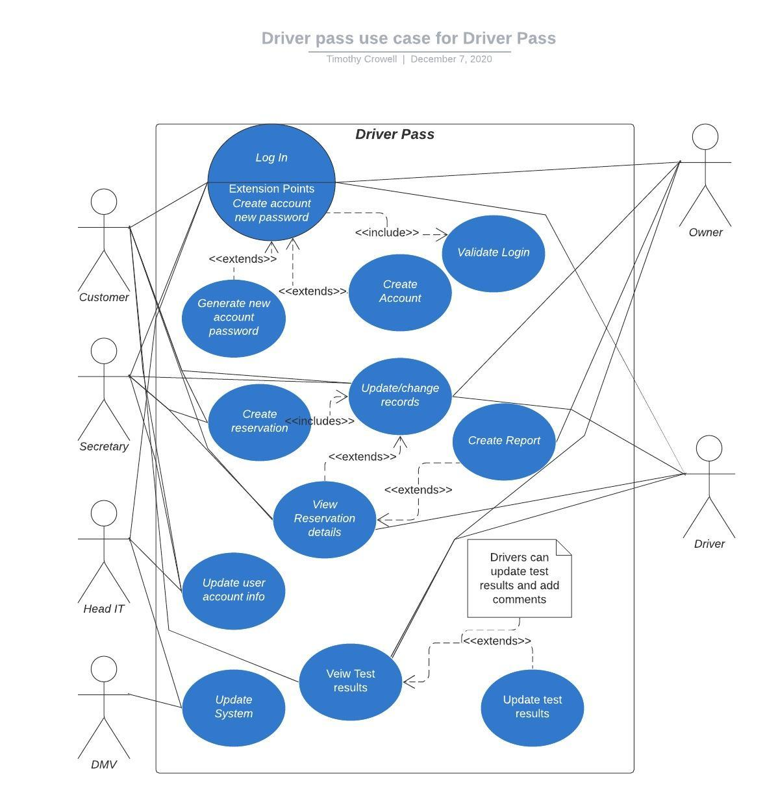

### UML Activity Diagrams

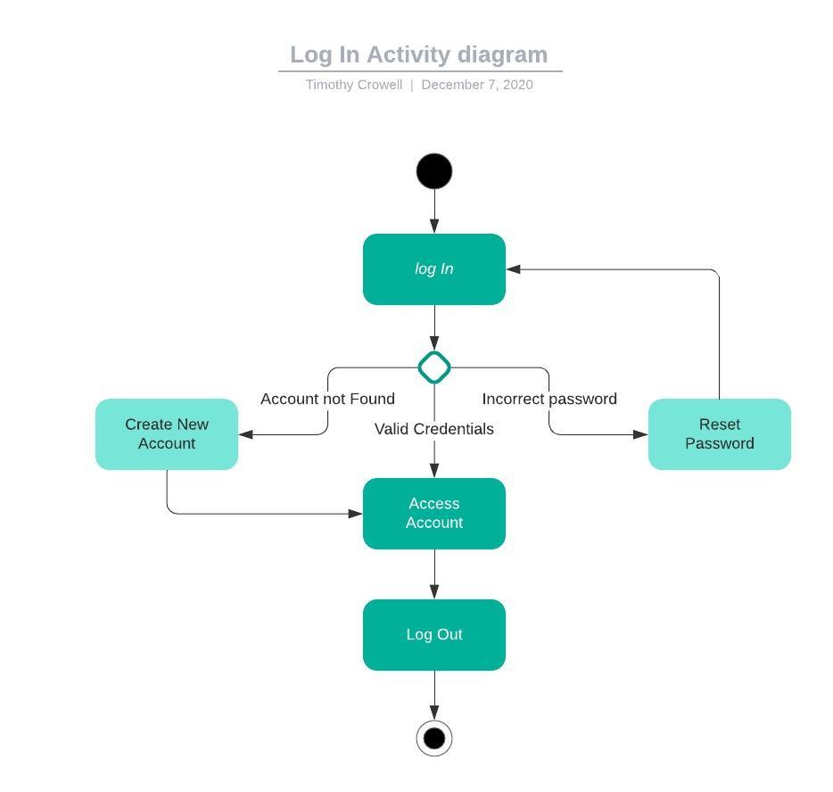

## Test Results Activity Diagramk

### UML Sequence Diagram

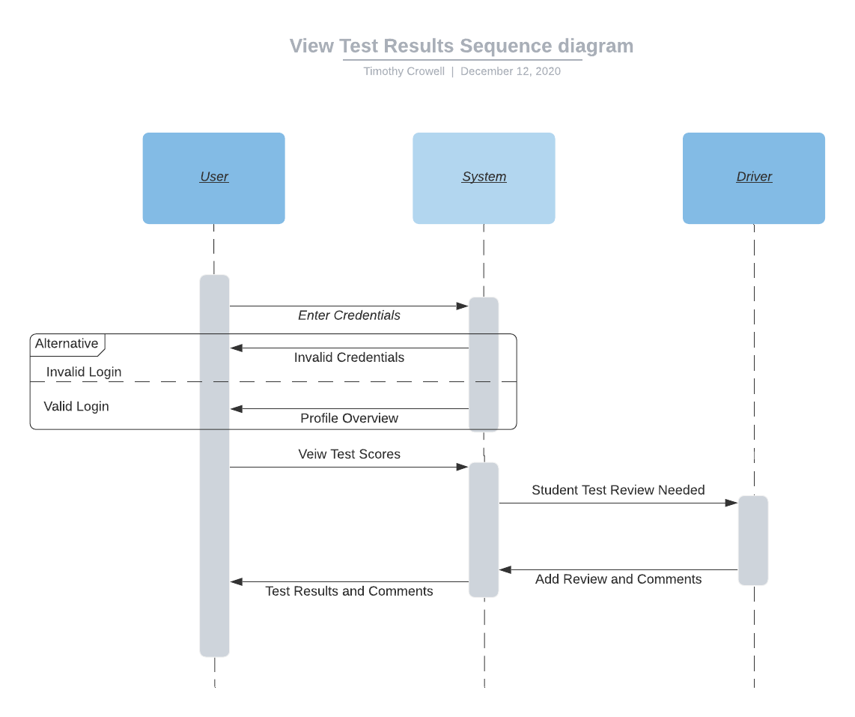

### UML Class Diagram

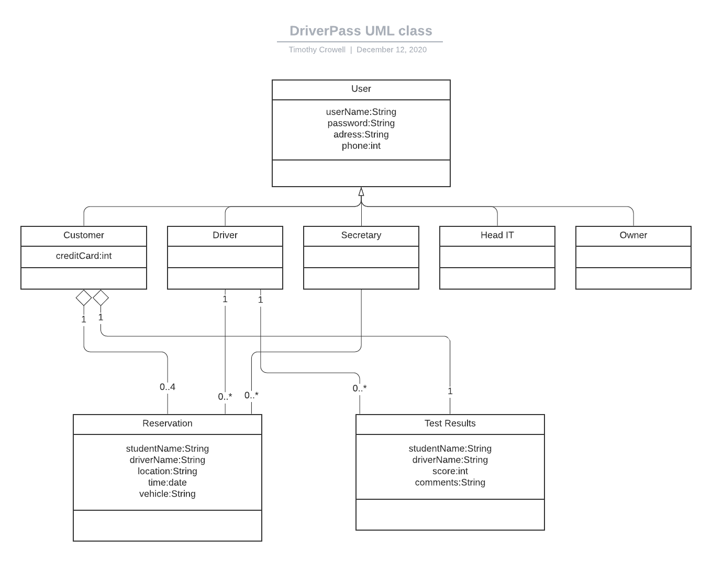

## Technical Requirements

One of our technical requirements is that users need a stable web browser to access the system. Since our system is run in a web-based environment on a cloud computing platform, access and distribution are easy. Another Technical Function of the system is that it will need to have access to the DMV system for updates. Part of maintaining the reputation of DriverPass relies on having updated and accurate state and federal regulations. Another major technical requirement the system needs is role-based access control. This lets each of the employees interact with the system in the ways they need to without exposing sensitive information and functions to customers.